ELISHA JOY R. YUMANG

CAS-05-601P

ACTIVITY 3

# -*- coding: utf-8 -*-

"""

Created on Sat Feb 17 09:43:26 2024

@author: Elisha Joy R. Yumang

"""

import numpy as np

import matplotlib.pyplot as plt

prior_probs = np.array([[0.33,0.3],[0.2,0.17]])

plt.imshow(prior_probs, cmap= 'gray')

plt.colorbar()

for i in range(2):

for j in range(2):

plt.annotate(prior_probs[i,j], (j,i), color="red", fontsize=20, fontweight='bold', ha='center', va='center')

plt.title('Prior probabilities', fontsize=20)

def bayes_theorem(p_a, p_b_given_a, p_b_given_not_a):

not_a = 1 - p_a

p_b = p_b_given_a * p_a + p_b_given_not_a * not_a

p_a_given_b = (p_b_given_a * p_a) / p_b

return p_a_given_b

p_a = 0.0002

p_b_given_a = 0.85

p_b_given_not_a = 0.05

result = bayes_theorem(p_a, p_b_given_a, p_b_given_not_a)

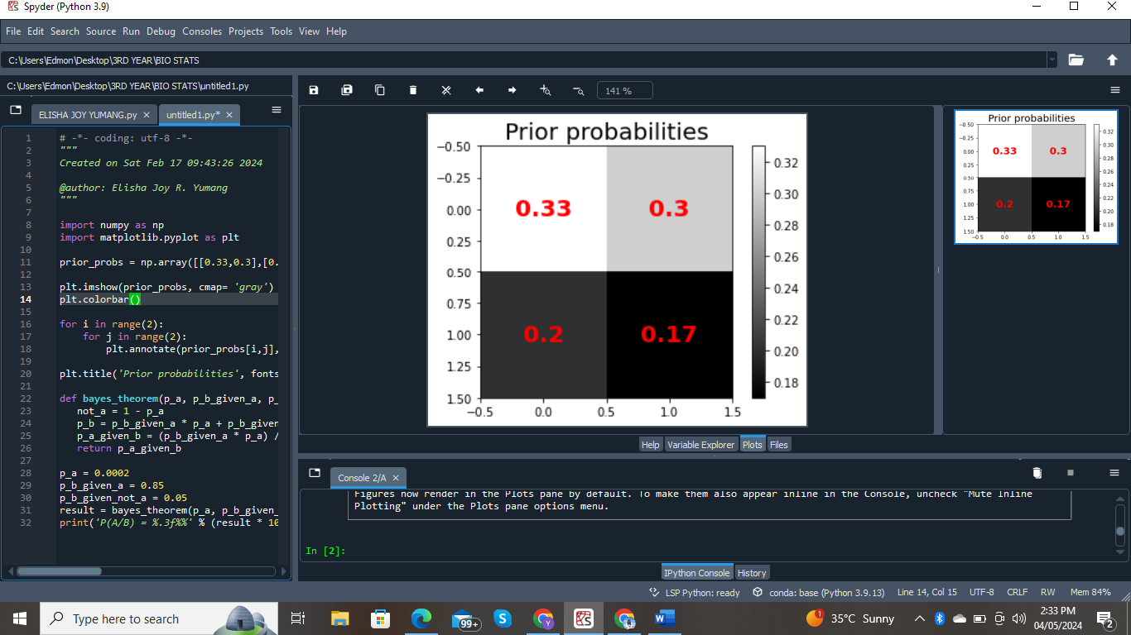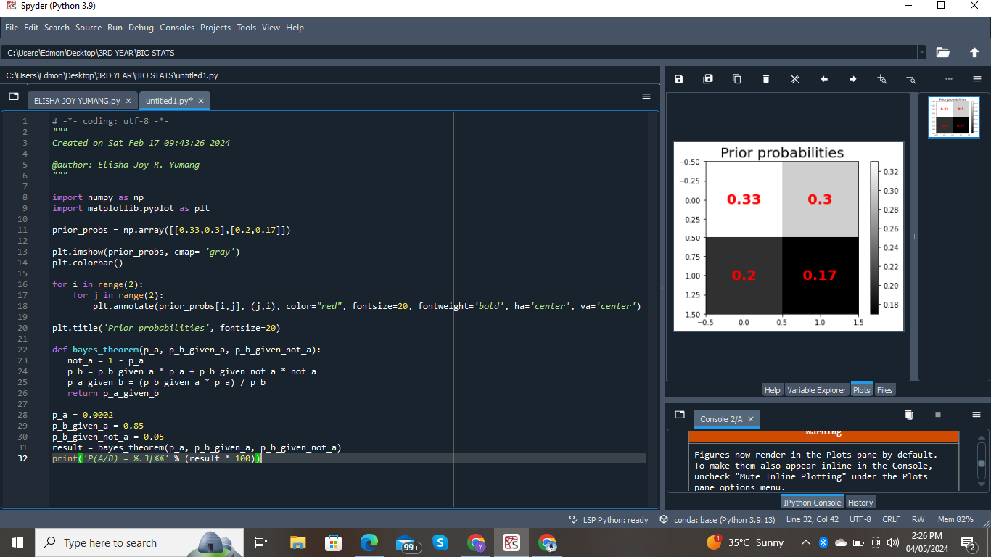print('P(A/B) = %.3f%%' % (result * 100))